D424 – Software Engineering
Task 3
Capstone Proposal Project Name: |   Main Ave Books Full-Stack Web Application
Student Name: | Kayla Pagan

Table of Contents
Application Design and Testing 3
Class Design 3
UI Design 4
Unit Test Plan 5
Introduction 5
Purpose 5
Overview 6
Tests that were performed cover the following: 6
Test Plan 6
Items 6
Features 6
Deliverables 6
Tasks 7
Needs 7
Pass/Fail Criteria 7
Specifications 7
Procedures 9
Results 9
Introduction 11
End User Guide 12
Accessing the website 12
Signing In 12
Using the site as a logged OUT user 13
Using the site as a logged IN user 18
Using the site as an ADMIN user 24
Developer Guide 27
Requirements 27
Cloning the GitLab repository 28
LINK TO HOSTED WEB APPLICATION 29
LINK TO GITLAB REPO 29

Application Design and Testing

Class Design
Below, I have provided an entity-relationship diagram to illustrate the structure and relationships between the tables in my application database. The design I chose supports basic functionalities and includes actions specific to administrative and signed-in users. These tables collectively support features such as borrowing, user reviews, tracking borrow history, and communication between administrators and users.
- The book table stores information about each book in the database, including title, author, description, availability, and an image associated with that book.
- The checkout table connects a user with the books they borrow and records the checkout date and the date for their return.
- The review table allows users to leave a review for individual books.
- The history table keeps a record of past checkouts. If the user returns a book, this table will record a past checkout in the history table.
- The messages table helps to facilitate communication between a user and an administrator. This table stores both questions and responses, as well as whether the issue is resolved or not.
This design makes sure that there is room for scaling in terms of managing operations, user activities, and administrative tasks.
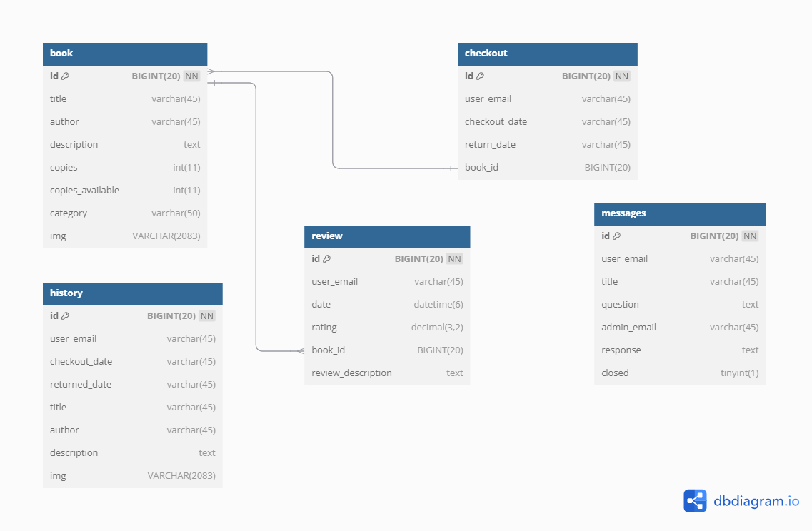

UI Design
The wireframe below represents a user-friendly interface that isn’t too crowded for users to skim around and find what they need. This design prioritizes simplicity and ease of use which makes it easier for users to navigate, use call-to-action buttons, and access several parts of the site. The home page demonstrates the use of core navigation options as all users need to have access to the home page and the search books feature. The page also provides a visually appealing hero section that contains a button to promote site exploration. This helps to guide users to get to the page they want to get to and make the interaction straightforward.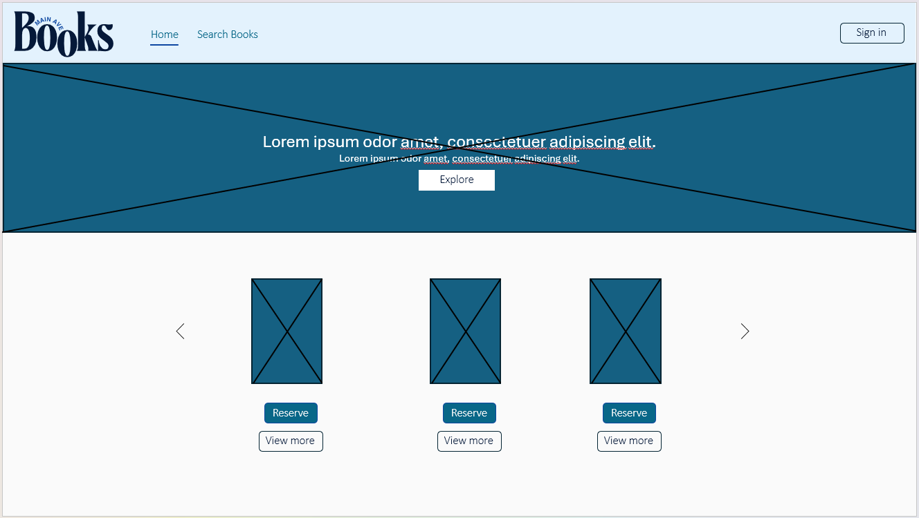
Figure 1: Wireframe

Unit Test Plan

Introduction

Purpose
The purpose of this unit test plan is to validate the functionality and reliability of both the frontend and backend portions of this web application. These tests ensure that critical features and services behave as they are expected to. If a failure occurs, there would need to be steps taken to debug, modify, and lastly re-run the tests to ensure that the desired functionality is restored.

Overview

Tests that were performed cover the following:
- Frontend: Verifies that navigation links (“Home” and “Search Books”) render correctly. Regardless of if a user is authenticated or not, these two navigation options need to be available. The test was conducted with Vitest and React Testing Library.
- Backend: Verifies that the application is connected to the database. Without a data source or a proper one, the application would fail to fetch books and any other data, which is essential for user experience and actions.

Test Plan

Items
- Development environment with all required dependencies. (Vite, TypeScript, and React for frontend and Spring Boot for backend)
- Testing tools like Vitest, React Testing Library, and Spring Boot Test.
- Database and configurations (applications properties set up with data source URL in spring boot)

Features
- Frontend: The “Home” and “Search Books” links are rendered in the navigation bar.
- Backend: The data source configuration is verified.

Deliverables
- Test scripts and test results (see below).
- Updated code for components or configuration files where necessary.

Tasks
- Set up a testing environment.
- Write test scripts for frontend Navbar component and backend data source.
- Execute the test scripts and analyze the test results returned.
- Update code if results show as a fail and then re-test until I get a pass.

Needs
- Vitest and React Testing Library are needed for frontend testing.
- Sprint Boot with Junit is needed for backend testing.
- A database that already exists and is configured.

Pass/Fail Criteria
- Frontend:
  - Pass: “Home” and “Search Books” links render onto the App component correctly and point to the expected href.
  - Fail: Links are missing, incorrect, or don’t point to the correct attributes.
- Backend:
  - Pass: The spring data source url found in the application properties file matches the expected database URL passed in the test.
  - Fail: The database is incorrect or shows up as null.

Specifications
Frontend Test Script:
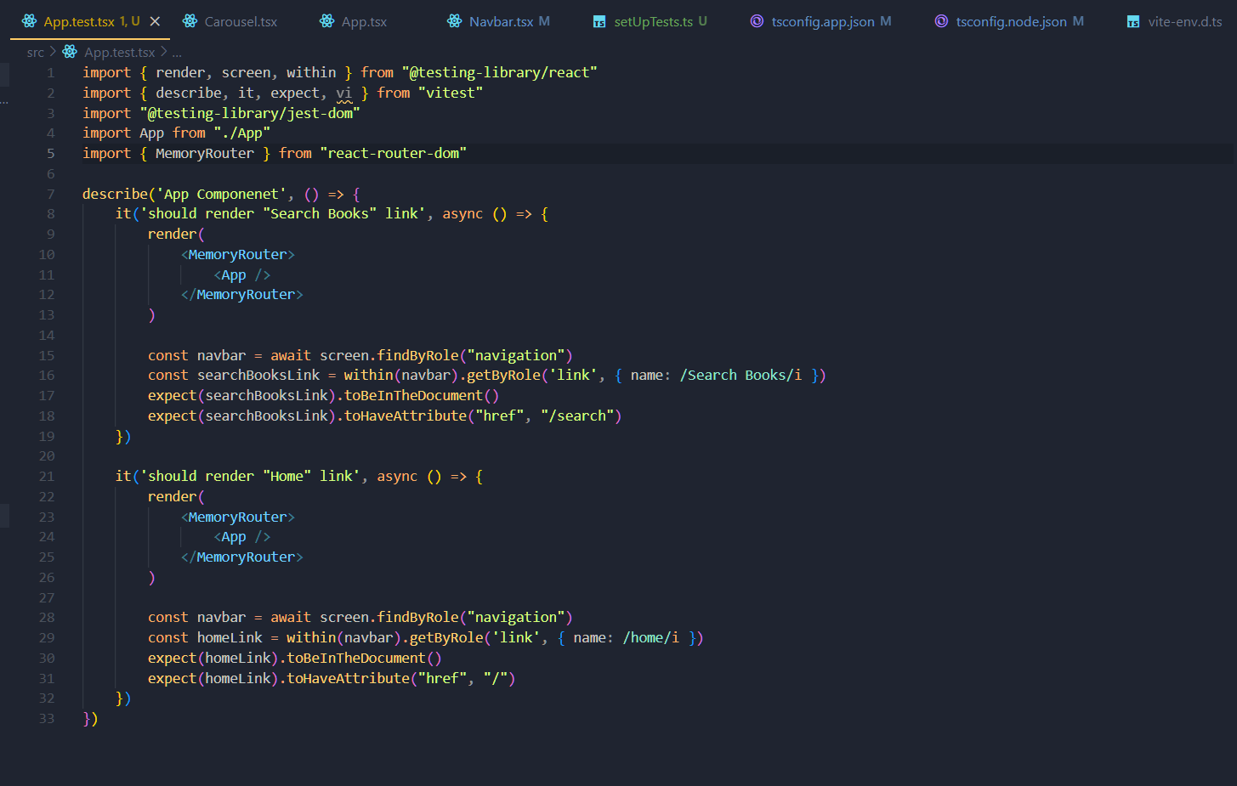

Backend Test Script:
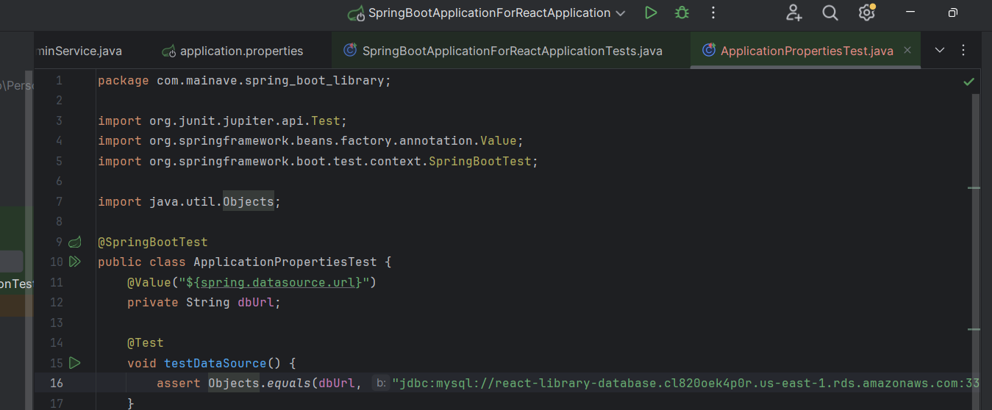

Procedures
  - Set up the development environment for testing and install any needed dependencies.
  - Prepare the database and all associated configurations needed to connect to the backend portion of the application.
  - Write and execute test scripts for the frontend and backend portions of the application.
  - Update the code wherever necessary and re-run tests.

Results
Frontend Test Results:
- The “Search Books” link in the navigation bar was rendered successfully so no changes needed to be made.
- The “Home” link in the navigation bar was rendered successfully so no changes needed to be made.
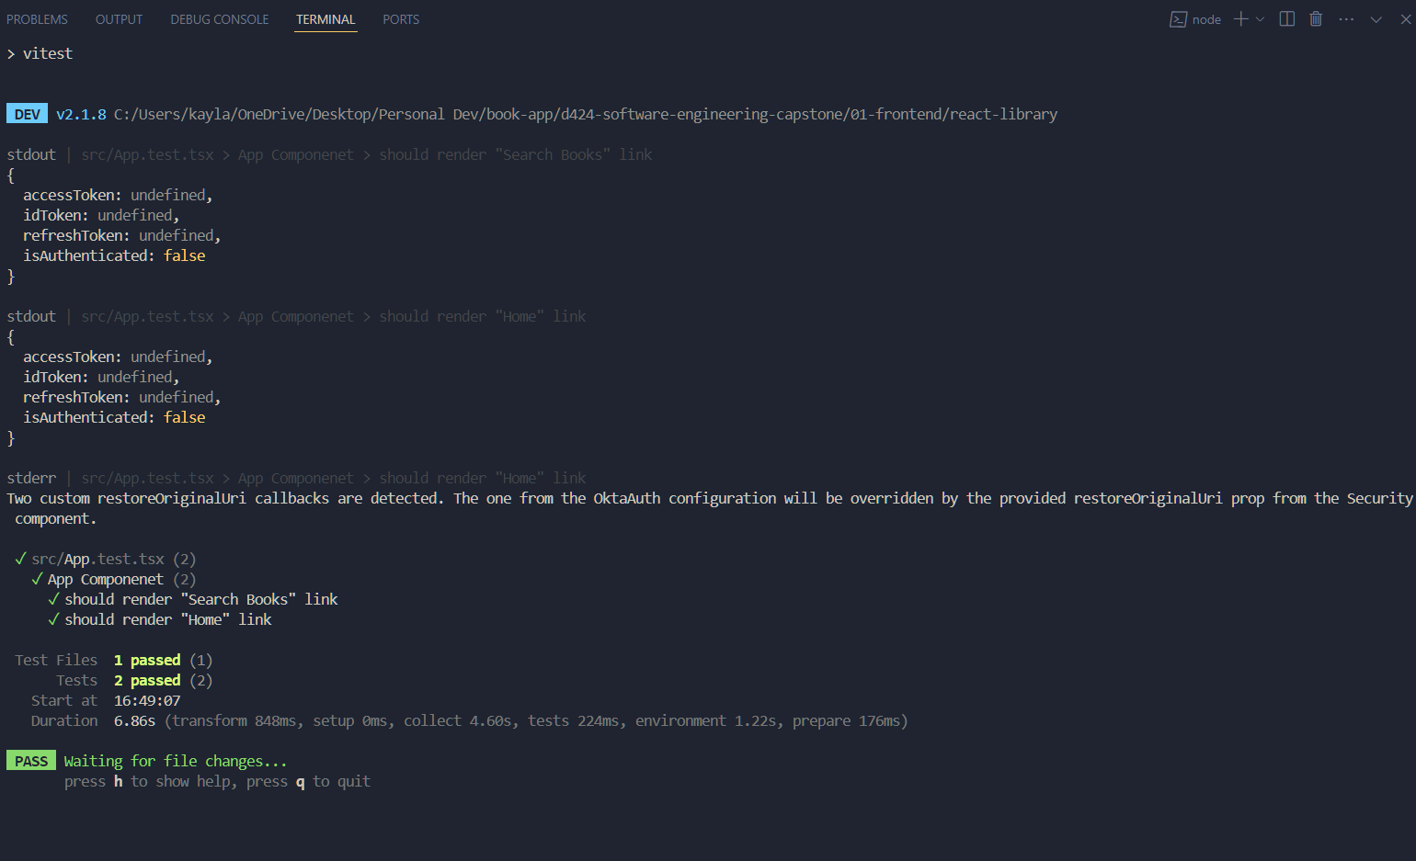

Backend Test Results:
- The data source URL matched the expected value passed into the test script so no changes needed to be made.
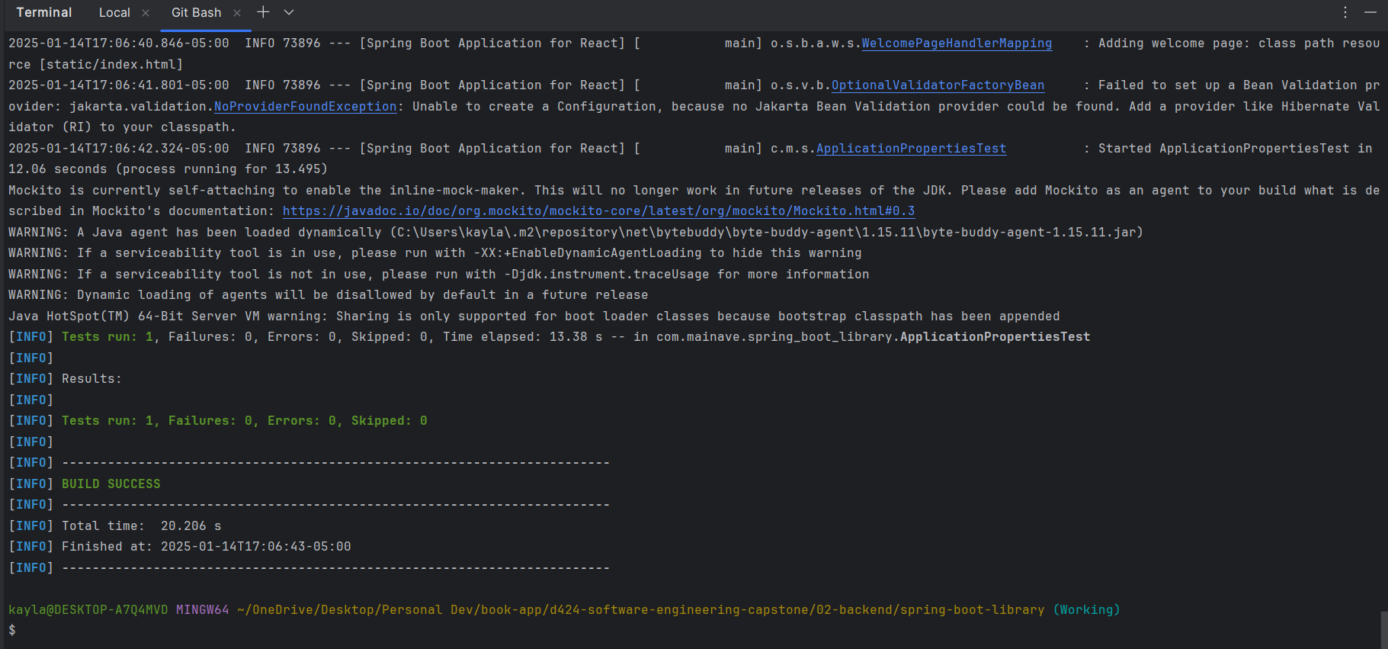

User Guide

Introduction
The following documentation will guide for using the Main Ave Books application. There will be two separate guides provided:
- User Guide for End Users: This will include detailed steps for installing, logging in, and using all the features and functions of the application as a customer or administrator. This guide ensures that end users can interact with the app seamlessly.
- Developer Guide: This will include detailed steps for developers who wish to set up the project locally. It will provide step-by-step instructions for installing dependencies, configuring the environment, and running the application locally.

End User Guide
This guide is designed to help end users navigate and utilize the website and use the available features effectively.

Accessing the website
- Make sure you have an internet connection and a up-to-date/modern browser.
- Access the website opening your browser (like Google Chrome) and visiting https://mainavebooks.com

Signing In
- To log in as a user, please click the “Sign in" button on the top right corner of the navigation bar.
- You will be redirected to a log in page where you are to fill out your username and password. (to test web application features as a test user please use testuser@email.com for the username and test1234! as the password)
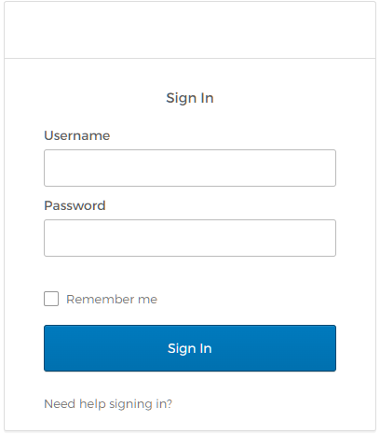
- Once you are logged in you will be redirected to the home page.

Using the site as a logged OUT user
- Once you access the site and are on the home page, you can view all books by clicking the “Search Books” button in the navigation bar, “Explore Top Reads” in the hero section, or the ”View More” button under the Carousel.
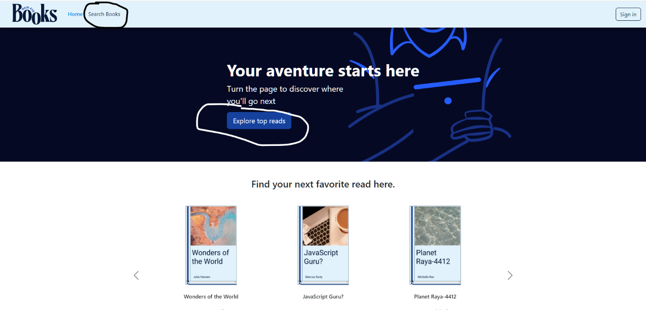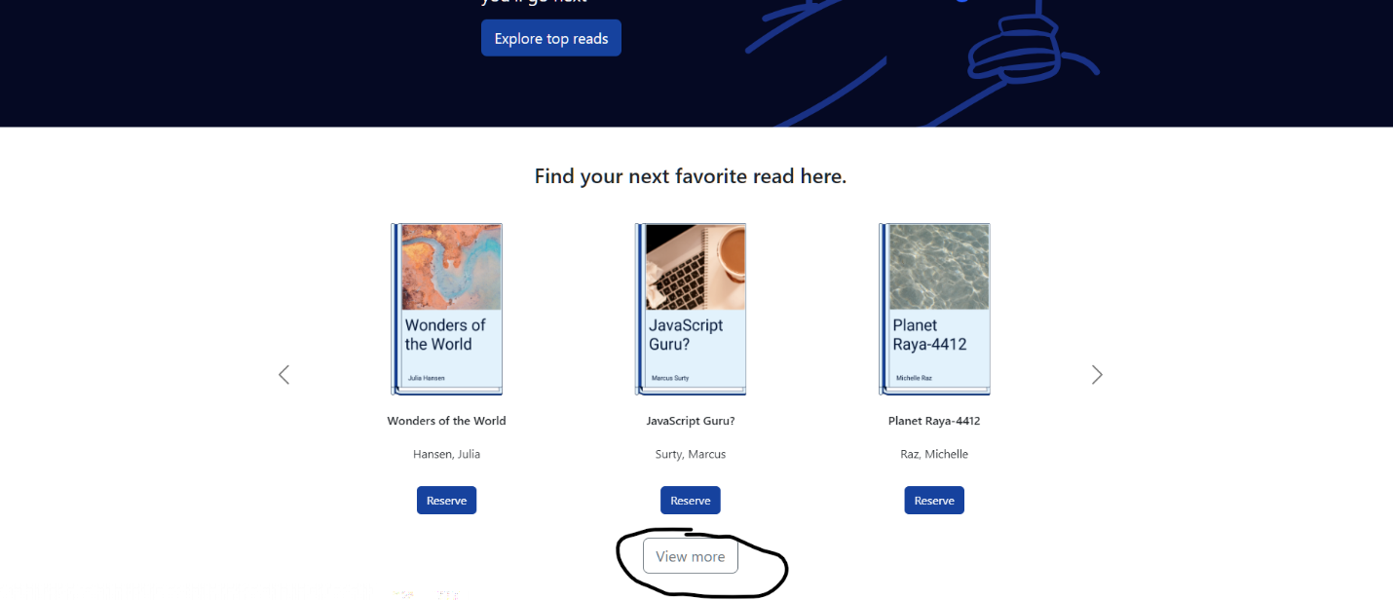
- Once you are on the search page, you can view all books by scrolling through the page and see more books on the next page by clicking on the number that follows the current page number you are on (ex: if you are on page 2 then you will click on “3” to get to the next page)
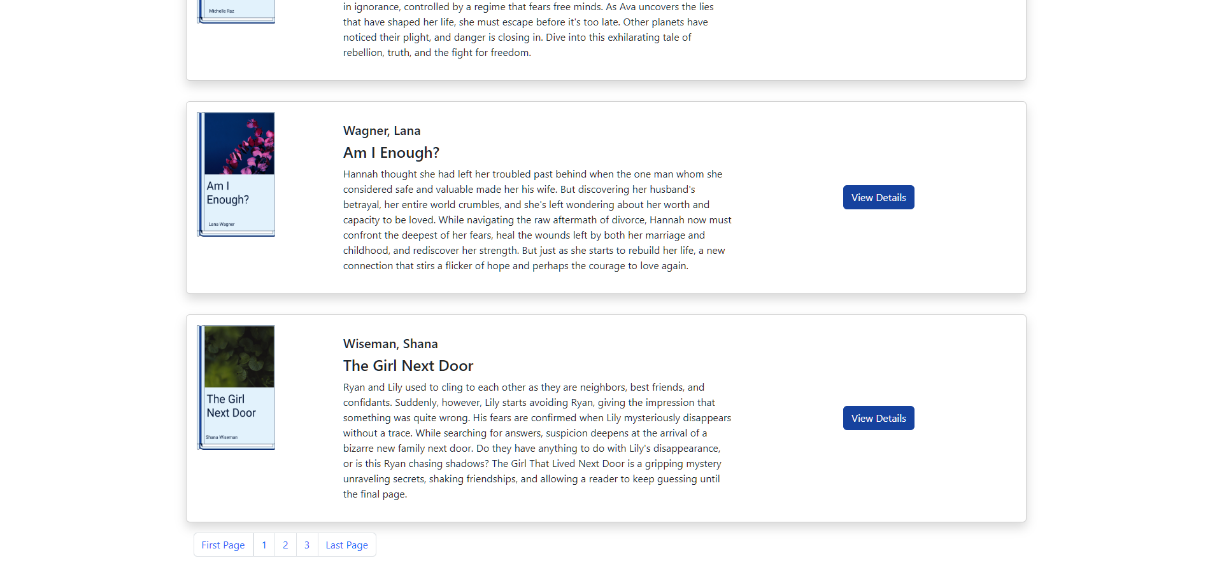
- To view details about a particular book please click on the “View Details” button that you see in the picture above.
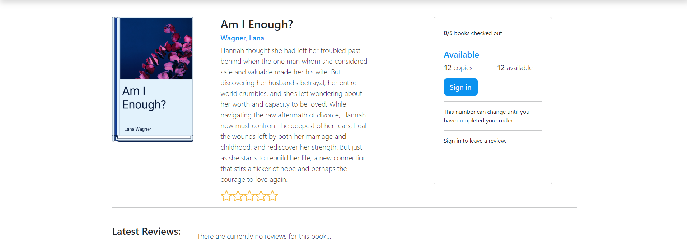
- You will be able to view the Book title, description, reviews, and copies. In order to leave a review or checkout with the book you will need to sign in by clicking the “Sign In” button.
- If you go back to the search page you can also search for a particular book by typing in a title or you can filter books by category
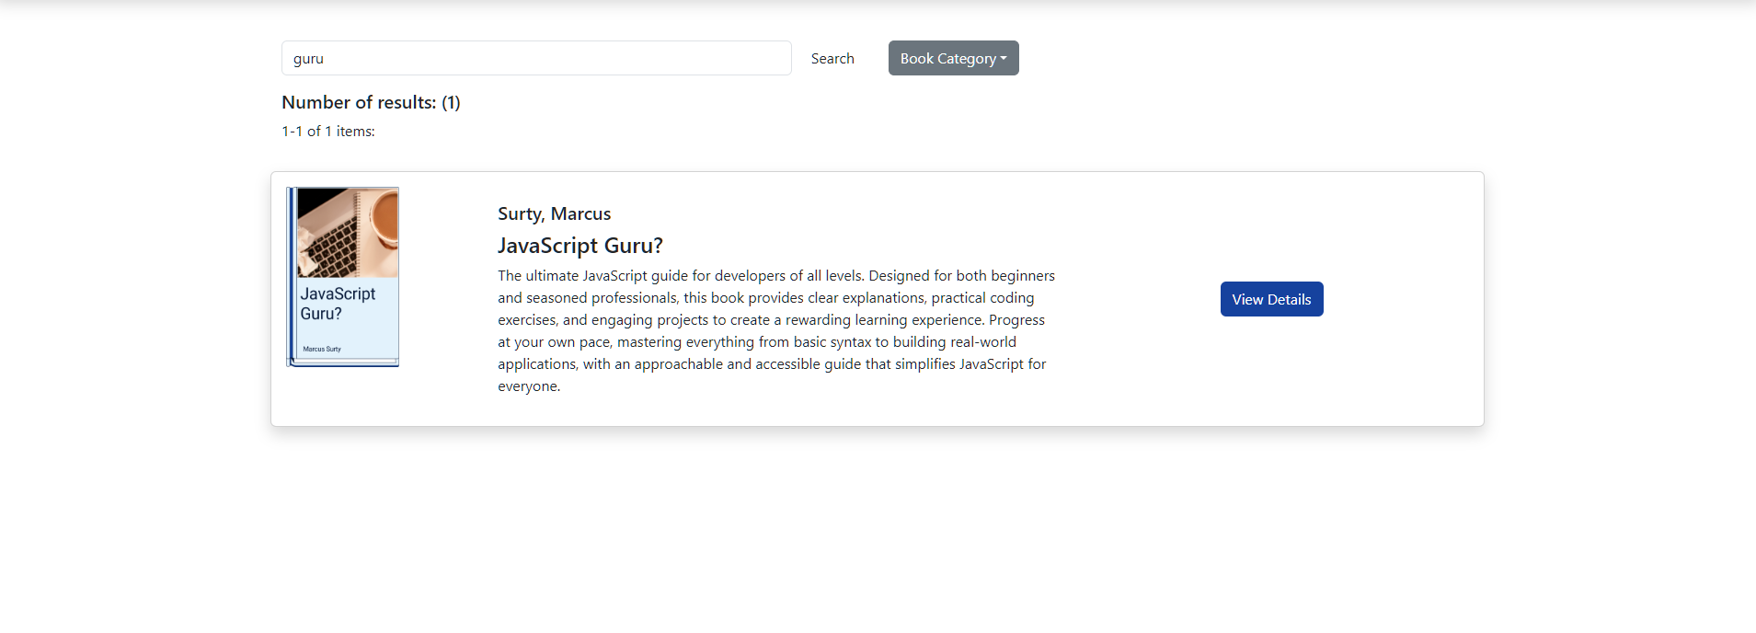
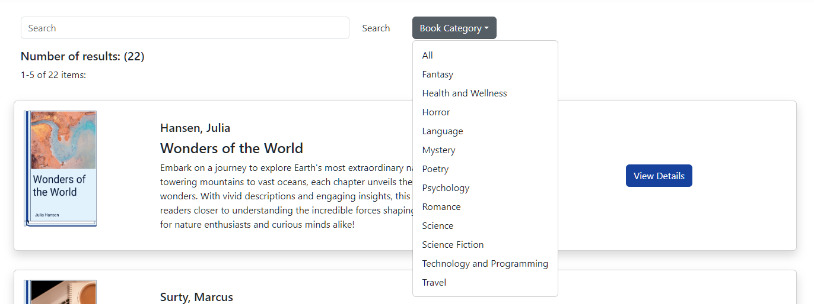
- If you travel back to the home page you will see two more sections which both need you to be a signed in user to access. The first button under “What have you been reading?” leads you back to the search page and the second button under “Can’t find what you’re looking for?” leads to a contact page where users can send questions to the administrators.
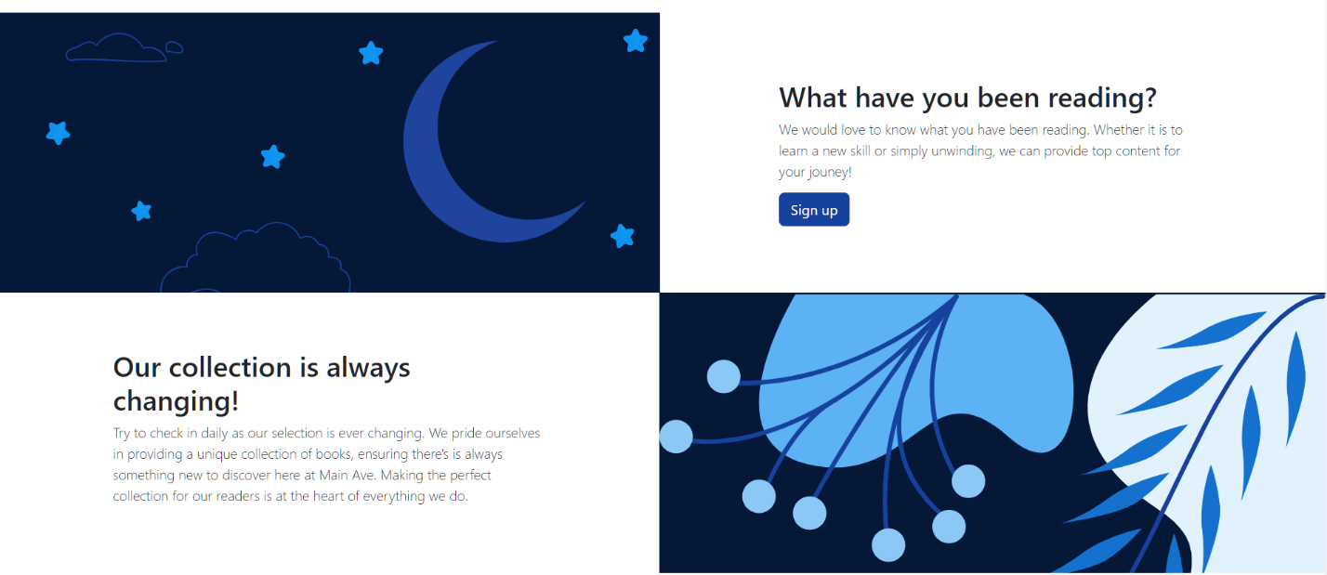

- If you click the “Reserve” button under a particular book in the carousel, it will lead you to the same detail page that the “view details” button in the search page leads to. As mentioned before though, users cannot perform checkout functions until they are signed in.
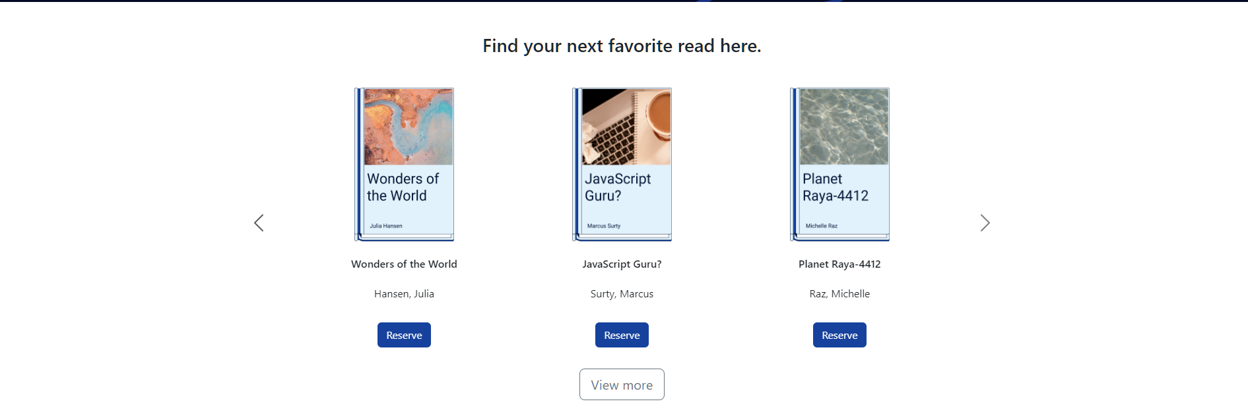

Using the site as a logged IN user
- All previous functionalities apply to logged in users except certain buttons will now be accessible. Now when scrolling through the home page you will now see the button under the “what are you reading?” section will not lead to the search page.
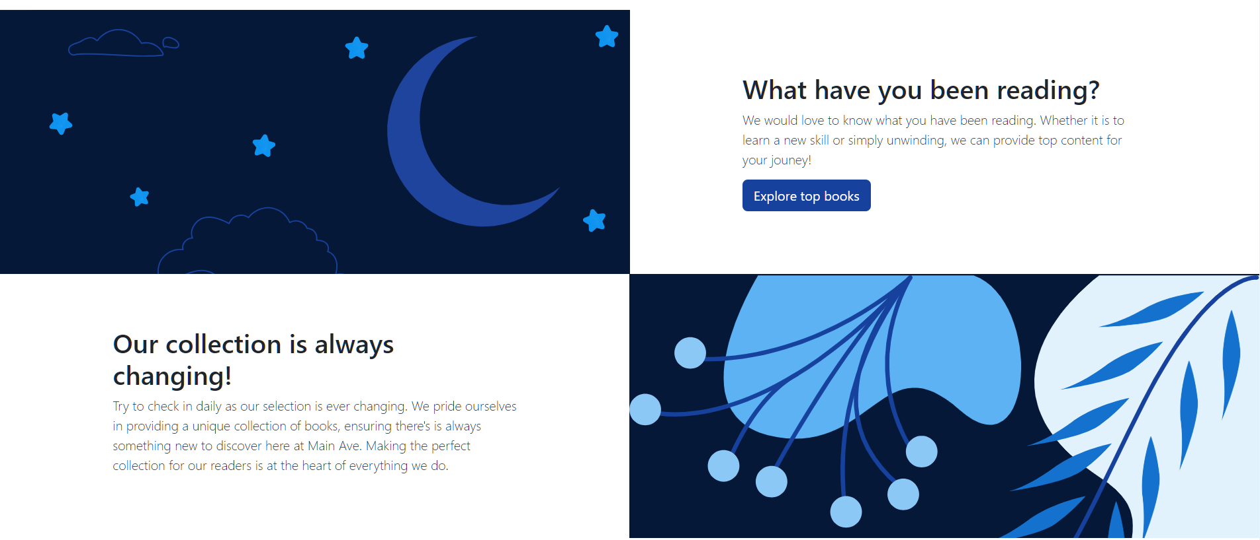
- The “Contact us” button will now lead to the messages page where you can enter a title and question then click “submit question” to send a message to the administrator. If you click the “Q/A Response/Pending” you can view all the questions you have submitted and see if they have a response or if it is pending.
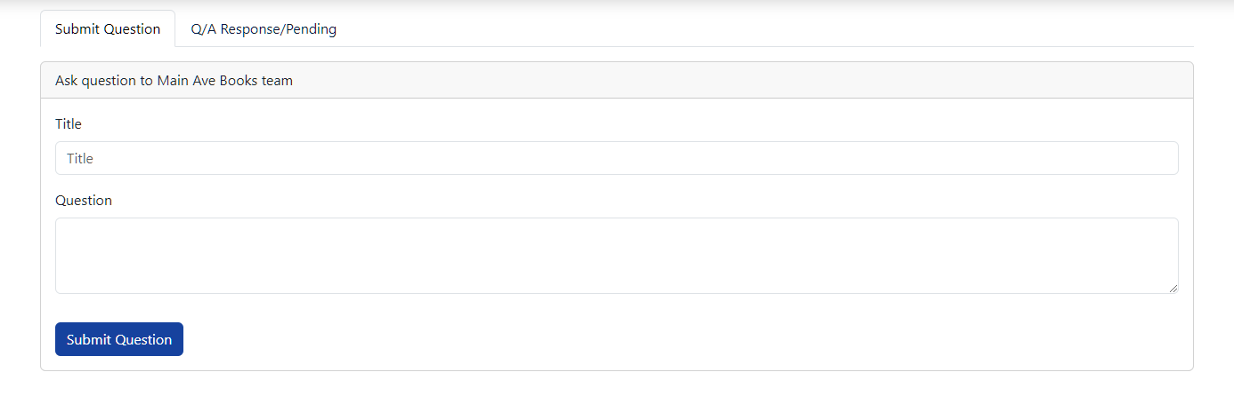
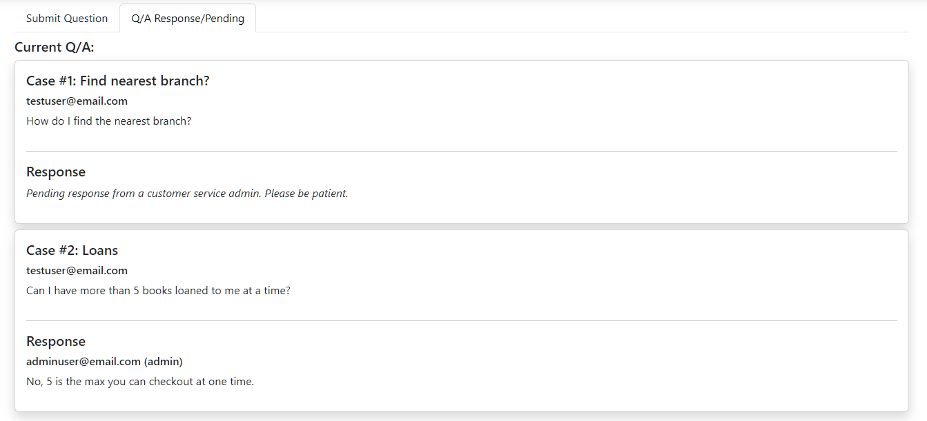
- You will now notice that as a signed in user, you will have an additional option in the navigation bar “Shelf”. Here you can find two tabs. One, for your current loans and a second for your history (which is all your past loans after they have been returned)
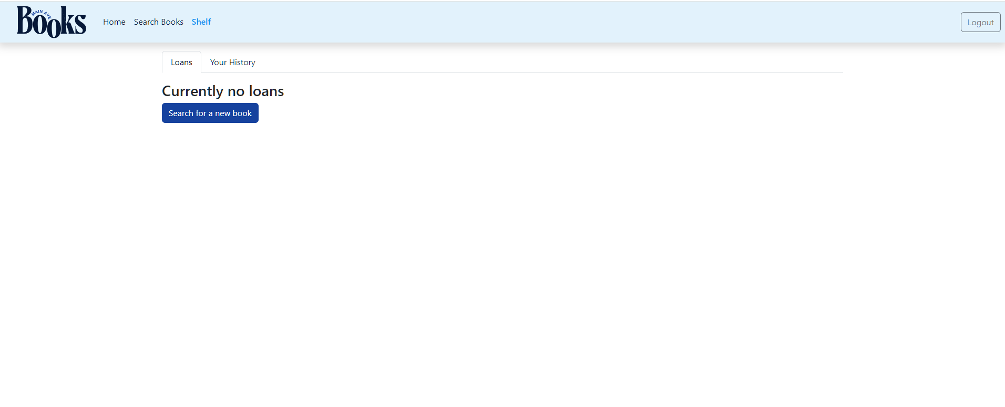
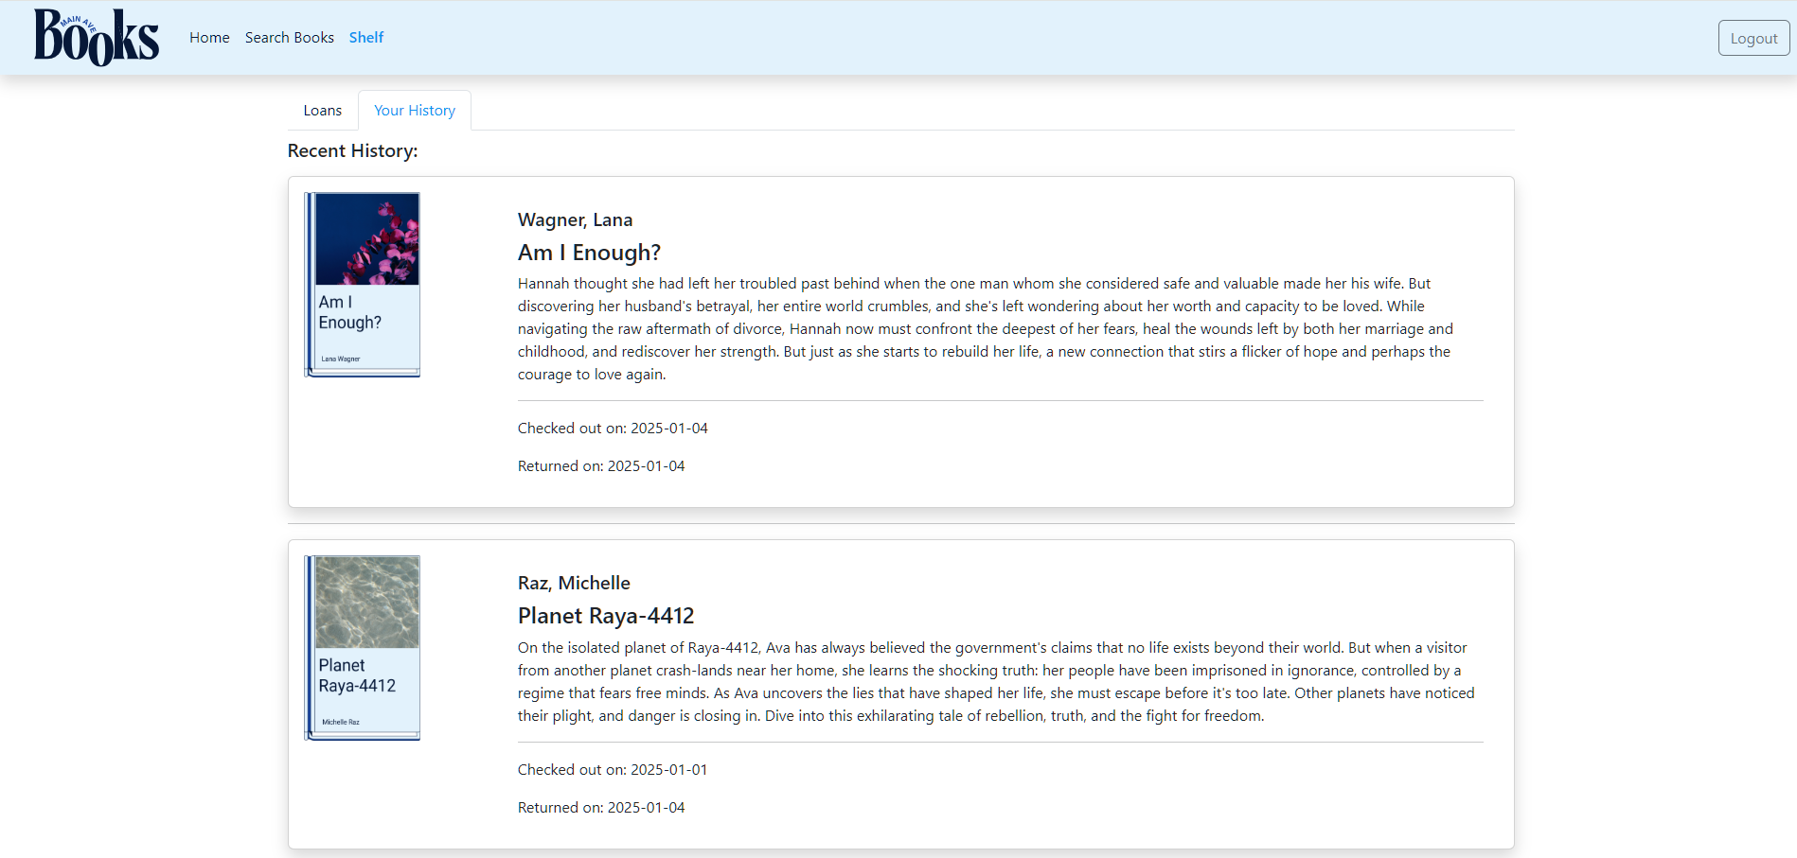
- If you would like to checkout a book, you can use the “Search for a new book” button under the loans tab or “Search Books” in the navigation menu and find a book you would like to checkout. This leads to the search page.
- Once there, you can click on the “View Details” button and you will now see a bit of a difference on the detail page. There is now a “Checkout” button.
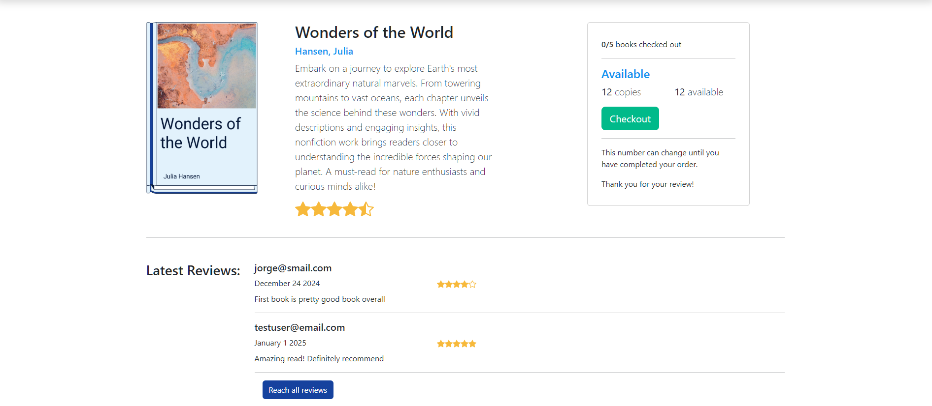
- Once checked out you should see feedback where the button was that confirms your checkout “Book checked out. Enjoy!”
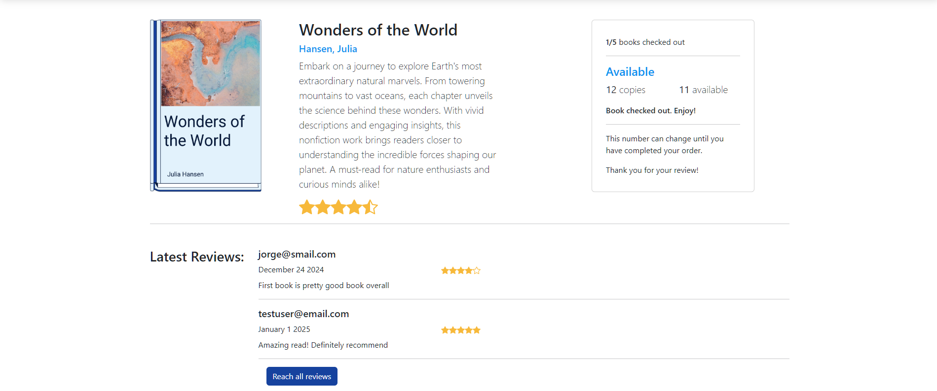
- Travel back to your shelf and the book should now be displayed under the loans tab
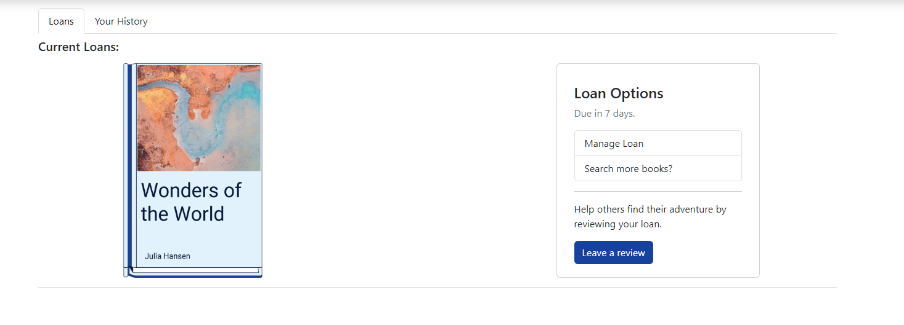
- You can select manage loan and this will allow for you to either return the book or renew the loan, as the loan will only be available for a 7 day period.
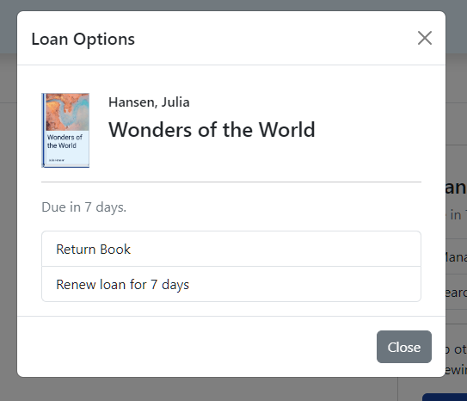
- If you click on the “Search more books” button you will be led back to the search page.
- If you click on the “Leave a review" button, you will be led to the detail page of that book where you can choose to leave a review.
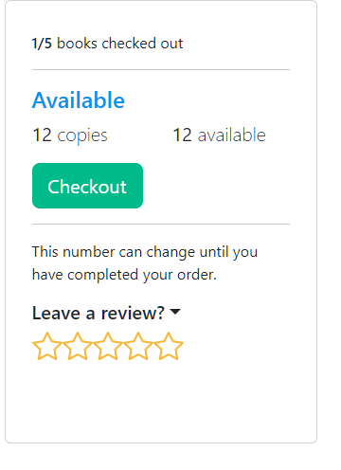

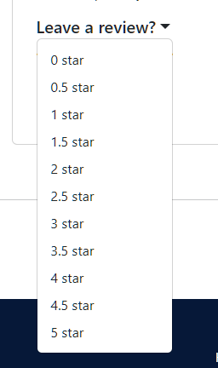
- To log out, please click on the “Logout” button in the top right corner of the navigation bar.

Using the site as an ADMIN user
- You have all capabilities of logged out users and logged in users. Please navigate to the login by clicking the “Sign in” button in the navigation bar.
- You will be redirected to the login page and here you will enter your username and password (for testing purposes please enter adminuser@email.com for the username and admin1234! for the password)

- You will now see an “Admin” option in the navigation bar. Please click this menu option.
- You will be redirected to the manage library page starting with the Add new book tab where administrators can add a new book to the database by entering the title, author, category, description, copies, and image (image is optional though). Once information is filled out, the “Add Book” button should be clicked to submit to database.
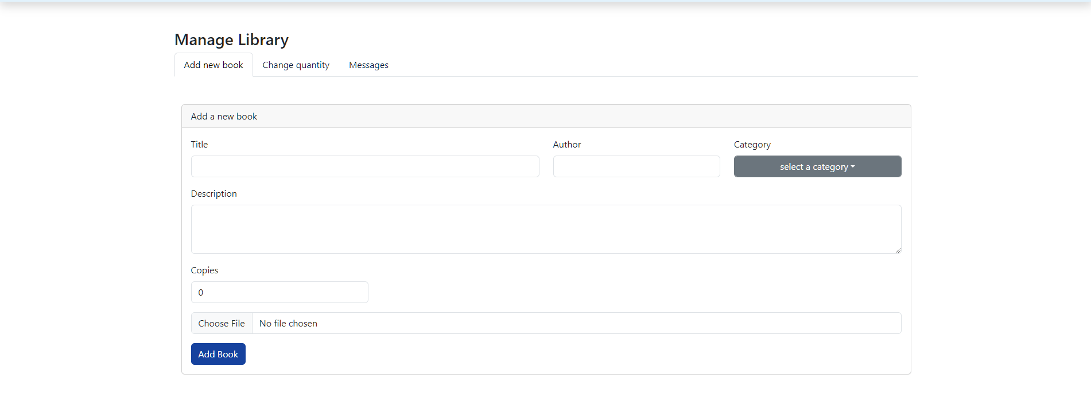
- The change quantity tab allows you to delete the book, add quantity, or decrease quantity.
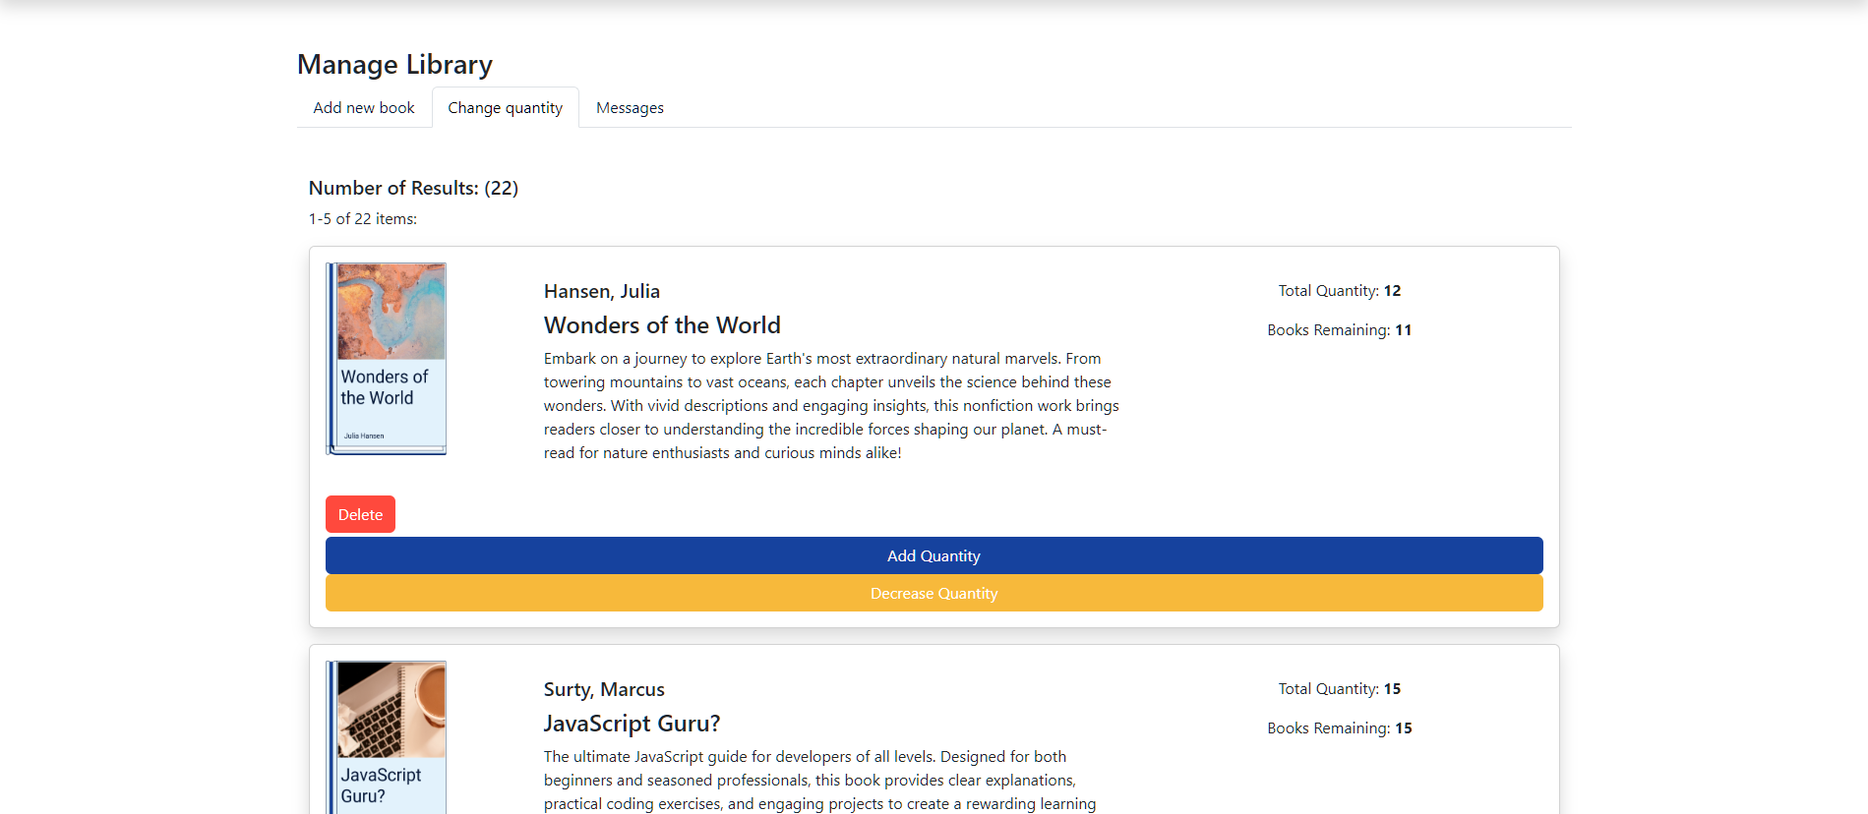
- The third tab is the messages tab, where you can answer user questions and submit a response by clicking the “Submit a response” button after entering a reply in the description textbox. You can also generate a report by clicking the “Generate Report” button and this will download the contents of the messages tab to keep track of user issues.
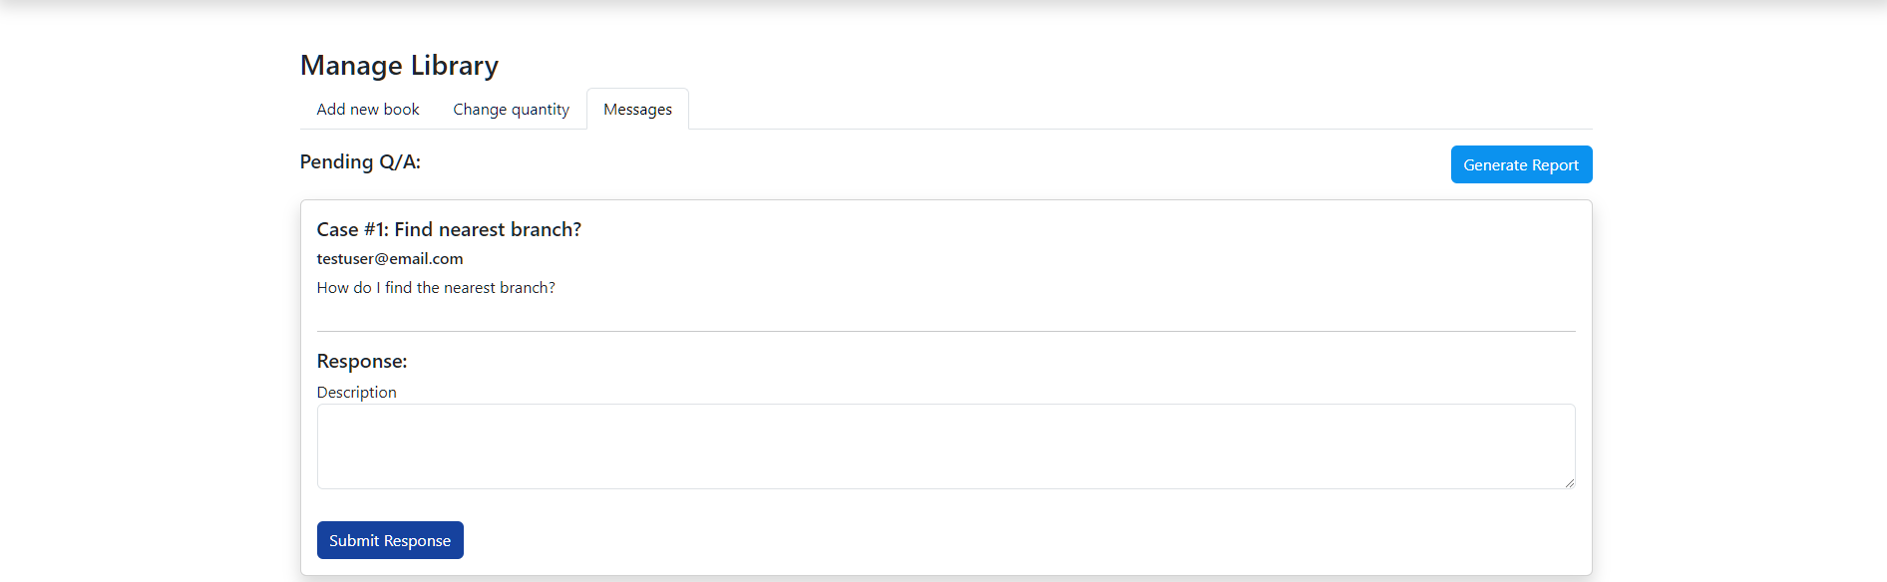

- To logout, please click the “Logout” button on the top right corner of the navigation bar.

Developer Guide
This guide provides steps to set up the Main Ave Books application locally for maintenance and testing. This will detail the dependencies needed to run the application.

Requirements
  - Java
  - MySQL
  - Node.js
  - IDE (vs code and intellij)

Cloning the GitLab repository
- Visit the GitLab repository with the following link: https://gitlab.com/wgu-gitlab-environment/student-repos/kpaga15/d424-software-engineering-capstone/-/tree/Working
- In the top right corner, there is a dropdown button named “Code”. Select and copy the Clone with https link.
- You will now open your terminal and run git clone <enter link you copied previously here>
- Please create a new branch so that you can make your own changes by going back to the repository in GitLab and clicking the + button where the dropdown menu will provide a “new branch” option.
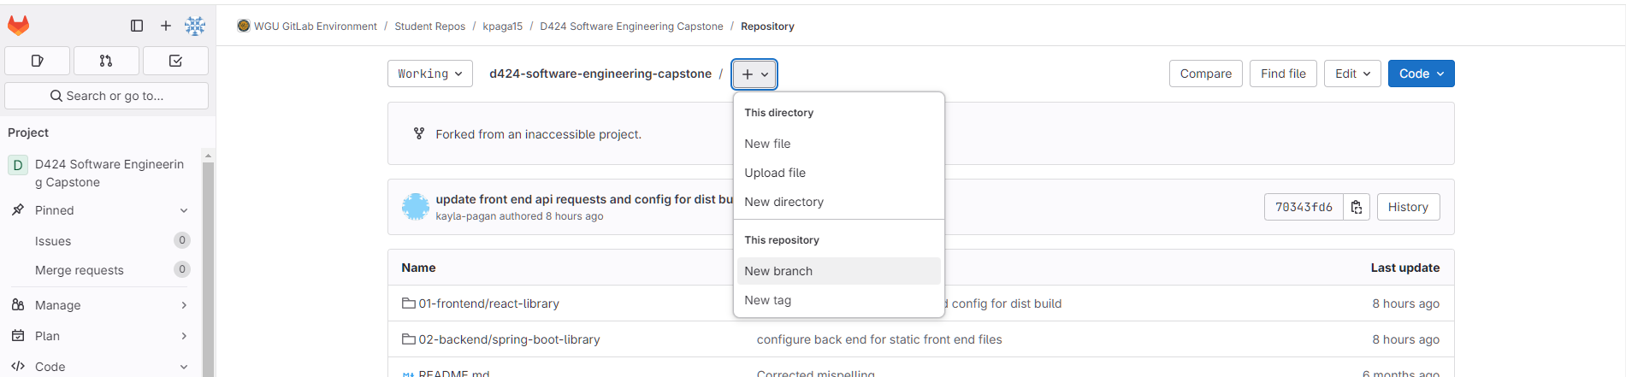
- Fill in a name for the branch and click create branch.
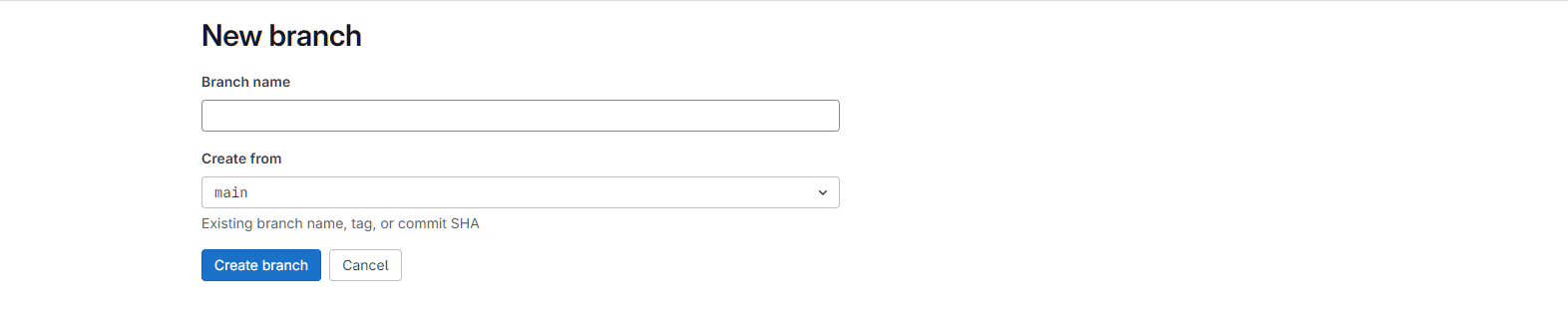
- Now go back to your terminal and type git checkout <fill in your branch name here>
- You can use cd 01-frontend/react-library to go to the frontend directory and make changes to the frontend.
- Type “npm install” in project terminal here to install frontend dependencies then “npm run dev” to start the development server.
- You can use cd 02-backend/spring-boot-library to go to the backend directory make changes to the backend.
- Type “mvn clean package” to build the project. Then, “mvn spring-boot:run” to run the backend.
- Then after running the backend, make sure the frontend is still running with “npm run dev”. Access the application locally at http://localhost:5173

Link to hosted web application
https://mainavebooks.com/

Link to GitLab Repo
https://gitlab.com/wgu-gitlab-environment/student-repos/kpaga15/d424-software-engineering-capstone/-/tree/Working

Sources
All images used in this project were sourced from Canva (https://www.canva.com)

